R. Reports Menu: A. Activity Report

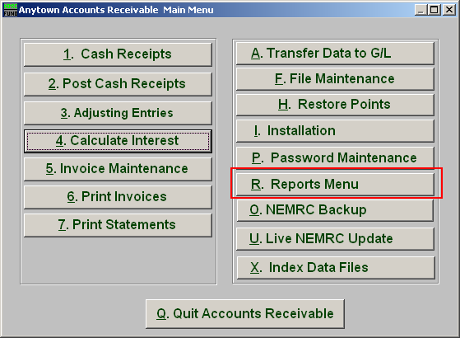
Click on “R. Reports Menu” from the Main Menu and the following window will appear:

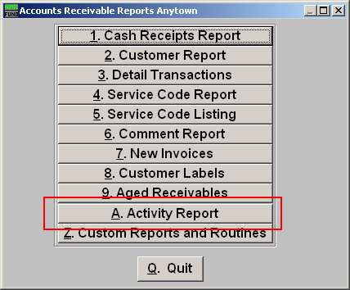
Click on “A. Activity Report” from the Reports Menu and the following window will appear:
Activity Report

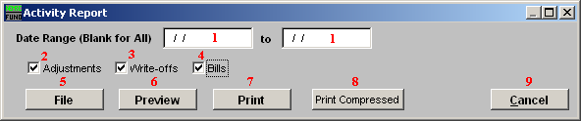

- Date Range: Enter the start date of transactions you want the report to begin with and the transaction date you want the report to end with.

- Adjustments: Select “Adjustments” if you want the report to include any adjustments made within the above entered dates.

- Write-offs: Select “Write-offs” if you want the report to include any write-offs made within the above entered dates.

- Bills: Select “Bills” if you want the report to include any bills made within the above entered dates.

- File: Click this button to save on this computer. Refer to GENERAL FILE for more information.

- Preview: Click this button to preview. Refer to GENERAL PREVIEW for more information.

- Print: Click this button to print. Refer to GENERAL PRINTING for more information.

- Print Compressed: Click this button to print the report. This is different from the “Print” option in that it will use less paper for the same report.

- Cancel: Click “Cancel” to cancel and return to the previous screen.

